

NCIA – National Cancer Imaging Archive

Architecture Overview


Document Change Record
Version Number | Date | Description
1.0 | 01/05/06 | Initial document
1.1 | 09/20/06 | Revised for Release 2.0

TABLE OF CONTENTS
1. Introduction 1
1.1 PROJECT BACKGROUND 1
1.2 SYSTEM OVERVIEW 1
1.2.1 User Client Software 2
1.2.2 User Interface 2
1.2.3 Middle Tier 3
1.2.4 Back End 3
1.2.5 jBoss Application Server 5
1.2.6 File System 5
1.2.7 Database 5
1.2.8 MIRC 5
1.2.9 MIRC Field Center 6
1.2.10 Curation Tool 6

Introduction
The purpose of this document is to provide an overview of the architecture of the NCIA application.

PROJECT BACKGROUND
NCIA provides the cancer research community, industry, and academia with access to Imaging Archives that can be used for many purposes including the potential to assist in the development and validation of analytical software tools supporting: lesion detection and classification software, accelerated diagnostic imaging decision, and quantitative imaging assessment of drug response. The repository provides access to imaging resources that will improve the use of imaging in today's cancer research and practice by: increasing the efficiency and reproducibility of imaging cancer detection and diagnosis, leveraging imaging to provide an objective assessment of therapeutic response, and ultimately enabling the development of imaging resources that will lead to improved clinical decision support.
Clinical trials submit images to NCIA so that they can be made available to others. Researchers may then access NCIA to search for and download images. Images are stored in the Digital Imaging and Communications in Medicine (DICOM) standard. A DICOM file stores the digital image along with a series of tags that contain metadata about the image such as patient ID, study ID, patient weight, anatomic site, and many more.
Release 1.1 included image submittal and search functionality along with download.
Release 1.2 included support for user preferences, reports, annotations, role based security, and an improved search architecture.
Release 2.0 adds support for uploading curation data, searching curation data, a quality assurance tool, and a tool to aid in verifying submission.

SYSTEM OVERVIEW
The purpose of this section is to give an overview of the NCIA architecture. The following diagram shows the overall architecture of NCIA. An overview of each component is provided in the sections immediately following the diagram.
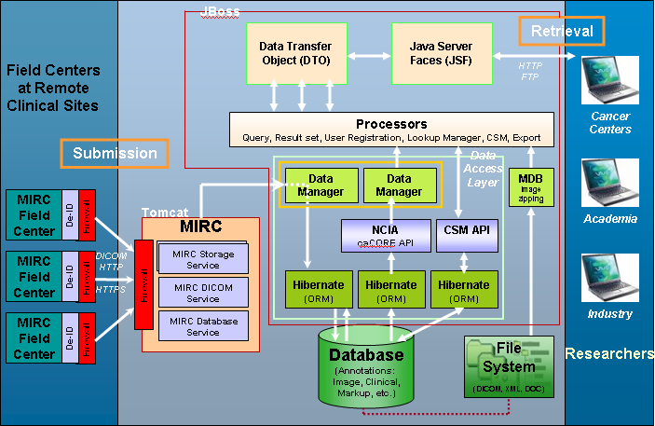

User Client Software
NCIA is a web based application. Users (cancer centers, academia, industry, etc) access NCIA through commonly available web browser software using the HTTPS protocol. JavaScript must be enabled in the browser.

User Interface
NCIA’s web-based user interface is implemented as HTML and JavaScript. The use of JavaScript is limited to improving usability only.
JavaServer Pages (JSPs) are used to generate dynamic HTML based on user actions. JSPs are a combination of HTML, Java Code, and custom JSP tags that get compiled into servlet classes.
JavaServer Faces (JSF) is used to simplify development of the JSPs. JSF is helpful by providing:
- Custom tags that are used to generate form input fields such as text boxes, checkboxes and radio buttons.
- Configurable mechanism for mapping input in HTML forms into JavaBeans
- An event model that maps button or link clicks to methods on JavaBeans
- Configurable navigation model
The Tiles framework is used to create reusable page components.
JavaBeans known as “backing beans” interact with the JSF components in JSPs. Examples are SearchWorkflowBean, BasketBean, and SearchResultsBean. Each of these beans manages the UI interaction in certain areas of the application.
Data Transfer Objects (DTOs) represent lightweight versions of domain classes used for presentation. When data is retrieved from the database for presentation in the UI, it is placed into DTOs.

Middle Tier
The middle tier is responsible for bridging the gap between the user interface that presents data and the back end that retrieves and stores the data. Middle tier components are called processors or managers.
The most important middle tier component is the ResultSetManager, which processes search requests. Based on the type of search requested, it builds a query based on the search criteria, sends the query to the back end, gets the results and converts the results into DTOs that the user interface layer can understand.

Back End
The NCIA back end components provide access to persistence services for retrieving and storing data in the database. Hibernate, an open source tool, is used as the Object-Relational Mapping (ORM) software.

DataAccessProxy
Access to back end components goes through the DataAccessProxy, which provides methods for searching and storing data. Each instance of DataAccessProxy is initialized to use the appropriate DataAccess class based on the way in which data is being accessed.

caCORE SDK Data Access
caCORE provides a robust set of tools for accessing data using Java. Based on a Unified Modeling Language (UML) model of the domain classes and database structure, the caCORE SDK generates a web application that provides access to the data represented by the modeled domain classes. The SDK simplifies the process of creating a back end because application developers do not need to worry about how data is being obtained from the database or generating mapping files for modeled domain classes. Access provided using the caCORE SDK is read only. caCORE leverages Hibernate for object / relational mapping.
The caCORE generated API can be accessed either remotely or locally. Accessing the toolkit remotely involves using the caCORE client classes to call a web application. The request and response is tunneled using HTTP. Local access involves directly calling the caCORE classes and avoids the overhead of HTTP tunneling.
Whenever possible, local access to the caCORE API is used to improve performance. Local access is used by the search infrastructure since the searching code has easy access to the SDK classes. Remote access is used by the ImageZippingMDB. Because of complexities with classloaders and details of the SDK’s implementation, it is difficult to call the SDK locally from the MDB, so remote access is used.
When searching, NCIA initializes DataAccessProxys to use either the local or remote caCore data access classes.

Hibernate 3 Data Access
When data needs to be updated instead of just read from the database, the caCORE API cannot be used. Instead, NCIA uses Hibernate version 3. When dealing with data that needs to be updated (with the exception of CSM data – see below), NCIA initializes DataAccessProxys to use the Hibernate 3 data access class. When there are requirements to update data, NCIA uses its own hand created domain classes and Hibernate mapping files.

Image Zipping Message Driven Bean
Users can download large sets of images from NCIA. To facilitate easy downloads, the image files are zipped up into one large file. Since the system often deals with several hundred megabytes or gigabytes of data, the zipping process can take a very long time. Because of this, zipping of very large files is performed using a Message Driven Bean (MDB).
MDBs are a special type of Enterprise Java Bean (EJB) that is called every time a message is placed on a queue. When a user requests a download of large amounts of data, NCIA places a message on a Java Message Service (JMS) queue. The MDB then accesses the message on the queue and processes it. The use of MDBs provide not only asynchronous behavior, but also allow for transactional integrity and failover.
Once the zipping process is complete, the zip file is placed on the NCIA FTP site for download and the user is sent an email. For small downloads (less than a configurable threshold), files are zipped synchronously while the user waits.

Curation Spreadsheet Message Driven Bean
Users can upload a spreadsheet of curation data to NCIA. Because there could be large amounts of data in the spreadsheet, the processing is done asynchronously. When a spreadsheet is uploaded, its data is placed on a queue which is then accessed by the CurationSpreadsheetMDB. The MDB processes the data and then sends an email when processing is complete.

Common Security Module (CSM)
The Common Security Module (CSM) is a NCICB component that is integrated into NCIA to provide authentication and authorization services. When users log in, NCIA calls the CSM to determine if the user is authentic. For authorization, NCIA calls CSM to determine the protection elements and roles to which the user has access. It can then filter results according to the user’s authorization.
The CSM also provides a web application called the User Provisioning Tool (UPT) that allows for maintenance of user authorization data.

jBoss Application Server
The user interface, middle tier, and back end components are run within the jBoss Java 2 Enterprise Edition (J2EE) application server. jBoss is an open source application server that provides a servlet container, an EJB container, the full range of J2EE 1.4 features as well as extended enterprise services including clustering, caching, and persistence. NCIA runs on jBoss 4.0.2.

File System
DICOM files and any associated annotations files are stored in the file system. The MIRC software places files on the file system when they are submitted in a directory structure that reflects the organization of images by patient, study, and series. Each image record in the database stores the image’s file system path.
Zipped images files that are ready for download are also placed in the file system.

Database
Oracle Relational Database Management System (RDBMS) software is used as the persistent store for NCIA application data. Java classes access the database using the Java Database Connectivity (JDBC) API.

MIRC
Medical Imaging Resource Center (MIRC) software was developed by the Radiological Society of North America (RSNA). The goal of MIRC is to provide tools for sharing radiological images for education and research purposes. MIRC offers a simple way to identify, index and retrieve images, teaching files and other radiology information.
For NCIA, MIRC handles the submission of images, storing images in the file system, and exporting images to the database. After images are submitted to the database, the private DICOM fields are anonymized so that they are not available to users who download the images.
MIRC is run on Tomcat, an open source servlet container developed by the Apache Software Foundation.

MIRC DICOM Service
The MIRC DICOM Service allows for DICOM images to be submitted from field centers using the DICOM protocol.

MIRC Storage Service
The MIRC Storage Service places submitted DICOM files into a directory structure in a directory structure that reflects the organization of images by patient, study, and series.

MIRC Database Service
The MIRC Database Service provides a hook for developers to include custom code that will export the DICOM information to a database. For NCIA, the database export process extracts selected data from the DICOM header fields and stores it in the NCIA table structure.
Hibernate 3 is used to interact with the database. Mapping files are generated using the caCORE SDK, but are then modified to allow for updates instead of reads.

MIRC Field Center
MIRC Field Center along with MIRC File Sender software is used to submit images to MIRC from the sites where they are generated (the “field center”). Typically, images are generated as part of a clinical trial. MIRC Field Center is used by researchers at hospitals, cancer centers, and universities to send their images to a MIRC site for sharing.
Due to privacy regulations, personally identifiable information must be removed from images before they can leave the field center. MIRC Field Center software provides tools to anonymize any personally identifiable data that is found in the DICOM tags.

